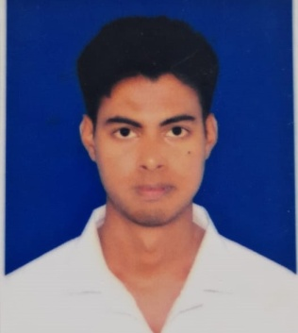**Resume of Md. Rukunuzzaman**

Chowrapara ,CO Bazar

Rangpur sadar, Rangpur.

 Contact No : +8801722458562

 Email :chem1913013brur@gmail.com

 Facebook :https://www.facebook.com/md.rukunuzzaman.737

❶ LinkedIn : https://www.linkedin.com/in/md-rukunuzzaman-50a779333

❼ GitHub :https://github.com/rukun11

**Career Objectives**

To develop career in dynamic and challenging environment where hard work, strick discipline, sincerity is welcomed. I have a desire to utilize my technical skill, talent, creativity, and sincerity for the better achievement of the organization.

**Personal Skill and Qualities**

* Hard Worker, Innovative and very responsible person.
* Able to work confidently under pressure in different situation to meet the deadline.
* Strongly believe in teamwork.
* Co-operative and Good communication skills.
* Strong analytical and problem solving skills.
* Organization &leadership competence with strong interpersonal relationship.

**Experience**

01

|  |  |
| --- | --- |
| * Organization Name : | Training Institute For Chemical Industries (TICI),Polash,Norsingdi,Bangladesh. (Central Training Institue of BCIC) |
| * Course Name : | Industrial Training on Chemical Analysis and Quality Control. |
| * Department : | Analytical Chemistry & Environmental Science. |
| * Duration : | Four Weeks. (21-09-2024 to 17-10-2024) |

02

|  |  |
| --- | --- |
| * Institude Name : | Zilla Parishad Computer Alor Pathe, Rangpur. |
| * Course Name : | Computer Office Application |
| * Duration : | Three Months |

**Educational Qualification**

|  |  |  |  |  |  |
| --- | --- | --- | --- | --- | --- |
| Exam Title | Group/Mejor | Institute | Result | Passing year | Session |
| Bachelor of Science (B.Sc.) | Chemistry | Begum Rokeya University,  Rangpur | CGPA: 3.08 out of 4.00 | 2023 | 2019-20 |
| HSC | Science | Rangpur Government College. | GPA: 4.17 out of 5.00 | 2018 | 2016-17 |
| SSC | Science | Bir Uttam Shaheed Samad High School, Rangpur. | GPA: 5.00 out of 5.00 | 2016 | 2014-15 |

**Language Proficiency**

|  |  |  |  |  |
| --- | --- | --- | --- | --- |
| **Language** | **Reading** | **Writing** | **Listening** | **Speaking** |
| **Bengali** | Excellent | Excellent | Excellent | Excellent |
| **English** | Excellent | Good | Good | Good |

**Computer Skills**

* Microsoft Office : MS Word, MS Excel, MS Power Point.
* Internet Browsing.
* Basic knowledge of computer hardware and software maintenance and E-mail service.

**Extracurricular Activities**

* Program Management
* Debating
* Volunteer Activities
* Sports:
  + Cricket
  + Football
  + Volleyball
  + Badminton
  + Chess

**Hobbies**

* Reading Book
* Traveling
* Gardening

**Personal Information**

Name : Md. Rukunuzzaman

Father’s Name : Md. Kudrat Ullah

Mother’ Name : Most. Yeasmin Sultana

Date of Birth : 11-10-2000

Gender : Male

Marital Status : Unmarried

Nationality : Bangladeshi

Religion : Islam

Permanent Address : Barigram,Natore.

Current Location : Rangpur

Blood Group : B+

**Reference**

|  |  |
| --- | --- |
| **Dr. Md. Abdul Latif**  Associate Professor & Head of the Deparment of Chemistry  Begum Rokeya University, Rangpur.   Contact No: +8801798-100131   Emai : [latif503@brur.ac.bd](mailto:latif503@brur.ac.bd) | **Mostafa Kaiyum Sharafat**  Lecturer  Department of Chemistry  Begum Rokeya University, Rangpur.  Contact No : +8801734785596  Email : mksharafat10@gmail.com |

**Declaration of Authenticity**

I hereby solemnly declare that the information which i have provided is true according to my knowledge and will be able to submit all needful documents in support of the aforementioned information if required.

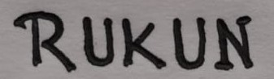

|  |
| --- |
| Md. Rukunuzzaman |
|  |